**GENERAL HUMAN BIOLOGY – YEAR 12**

**TASK 9 – INFECTIOUS DISEASE AND VACCINE TEST**

***MULTIPLE CHOICE (Total = 13 marks)***

|  |  |  |  |
| --- | --- | --- | --- |
| 1. | D | 7. | A |
| 2. | C | 8. | B |
| 3. | B | 9. | A |
| 4. | A | 10. | D |
| 5. | D | 11. | D |
| 6. | C | 12. | C |
|  |  | 13. | B |

***SHORT ANSWER SECTION (total = 19 marks)***

1. Which body system helps prevent you from getting disease? (1 mark)

* Immune system / lymphatic system

1. What signs of inflammation can you see in these images? (3 marks)

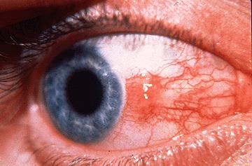 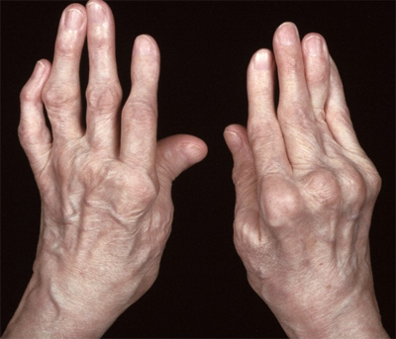 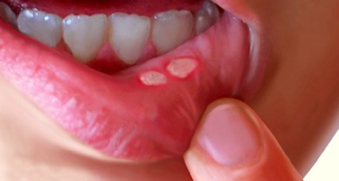   
Redness Pain / swelling Pain / Inflammation

1. To be infected by a pathogen, there are a number of linked stages, called the Chain of Infection, that must be satisfied (occur). State and describe each stage involved in the Chain of Infection?

(6 marks)

*½ mark per name, ½ per description*

* Infectious disease: any microorganism/pathogen that causes disease
* Reservoir: where microorganism/pathogen resides.
* Portal of exit: place microorganism/pathogen leaves the reservoir
* Mode of transmission: the way a microorganism/pathogen is transferred
* Portal of Entry: opening where microorganism/pathogen enters host’s body
* Susceptible host: people who are at risk of getting an infectious disease.

1. Fill-in the table below, comparing the features of bacteria and viruses (3 marks)

|  |  |  |
| --- | --- | --- |
|  | **How more copies are made inside a host** | **How pathogen is treated** |
| **BACTERIA** | They asexually reproduce / cell division / mitosis/binary fission (1) | Antibiotic (½) |
| **VIRUS** | Inject RNA into host cell forcing it to make new copies / hijack host cell (1) | Anti-viral (½) |

1. Draw a line to match the pathogens with their example (4 marks):

|  |  |  |
| --- | --- | --- |
| Bacteria |  | Tinea/Athlete’s Foot |
| Virus |  | Malaria |
| Parasite |  | Bird Flu |
| Fungi |  | E. Coli |

1. Parasites rarely kill their host. Suggest a possible reason. (2 marks)

*Any 2 for 1 mark each, any suitable response:*

* Have a parasitic relationship (1)
* Need to have the host alive to survive (1)
* Live off of the host (1)

***EXTENDED RESPONSE SECTION (Total = 11 marks)***

1. Graph problem
   1. Draw a line graph of the above data. (5 marks)

|  |  |  |
| --- | --- | --- |
| * Title (1) | * X-axis correct (1) | * Y-axis correct (1) |
| * Scale (1) | * Pencil and ruler (1) |  |

* 1. What is meant by the term symptom? (1 mark)
* Effects of the disease (1)

*Or anything suitable*

* 1. On the graph, show when the symptoms were apparent. (1 mark)
* Shows days 5-14

The incubation period is the time taken from infection to the first symptoms of the diseased.

* 1. Show the incubation period on the graph. (1 mark)
* First 4 days
  1. What is the smallest number of bacteria that caused symptoms in the subject? Explain your answer. (3 marks)
* 700 (1)
* During the time of symptoms present (1)
* Lowest amount of bacteria recorded (1)

*Or any suitable explanations*